Obituary
Robert C. Hughes
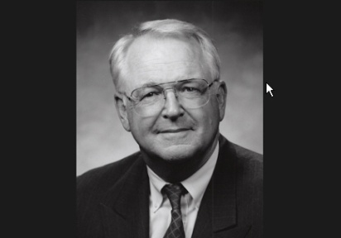

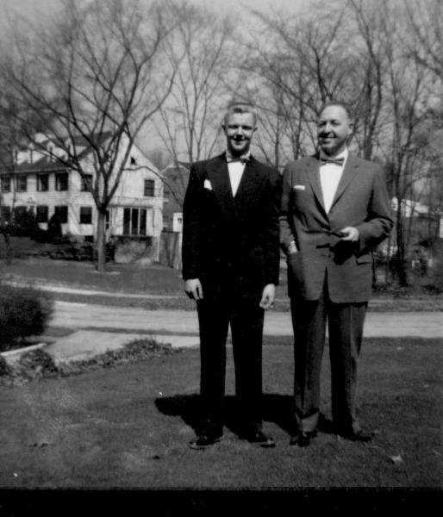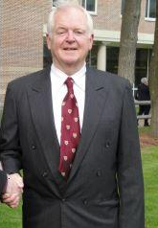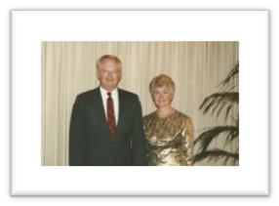
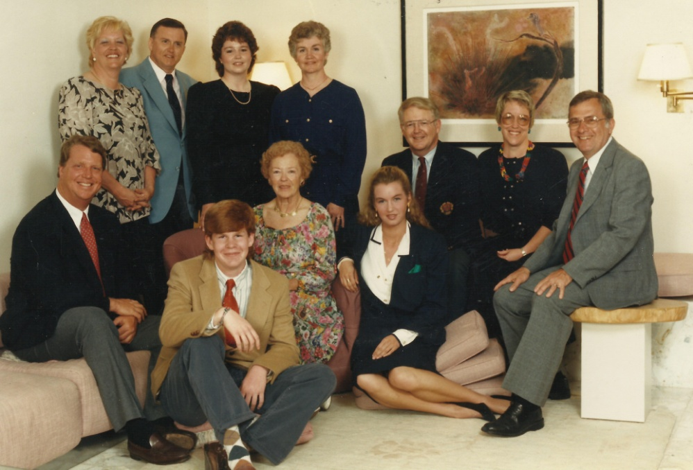

Hughes, Robert "Bob" Carey of Manchester-by-the-Sea, MA, died May 18th at the age of 73 due to cancer, with his family by his side.
Bob requested a very small ceremony that just included family, and his ashes are buried in Pleasant Grove Cemetery, Pine Street, Manchester-by-the-Sea, MA. His formal Obituary was posted in the Boston Globe:
http://www.legacy.com/obituaries/bostonglobe/obituary.aspx?pid=171327439
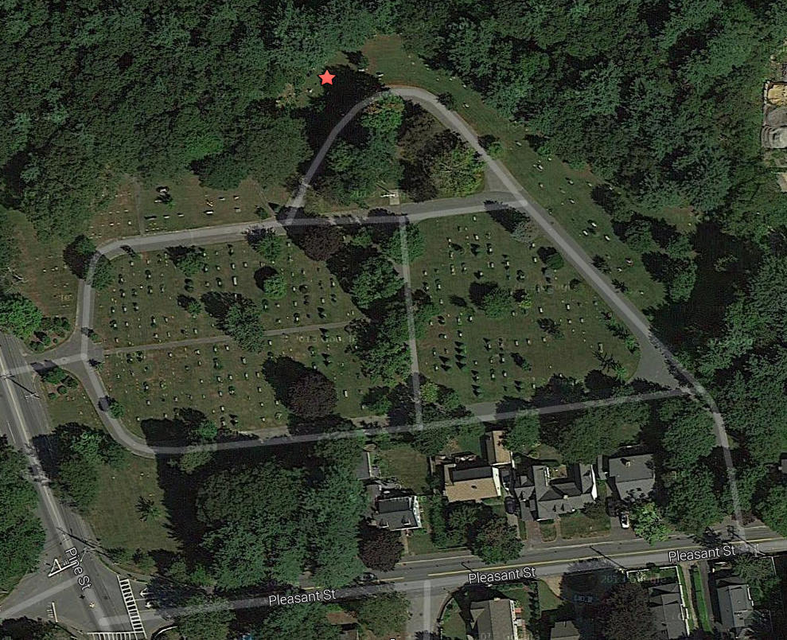

Bob is survived by his daughter Erin, and his son, Brant, along with Heather and their daughter, Hadley.

Bob was the oldest of 5 children born to James M. Hughes (1915-1963) and Jane Carey Hughes (1915-2002) who met in Lansing, Michigan. His siblings include; Kathleen Hughes Sapko, her husband Dave and their son, Jeff: Margaret Ann Hughes Bell: James M. Hughes Jr., and his wife Kathy: and Elizabeth Hughes-Zimbler, her husband, Lyle and two children, Will and Livie.

Bob’s early life was spent in Catholic schools in Youngstown, Ohio. Bob was influenced early in his life by a failure, flunking out at Ohio University. However, there is no doubt that after this failure, time in the US Army, and the death of his father, Bob learned the results of hard work, setting goals, and continuous improvement. When he returned from the Army he tackled Ohio University again and this time, graduated with honors while meeting his future bride, Karen Korb.

Bob took his new found success and completed his MBA at The Harvard University Business School. This taste of success, combined with the things he learned in the army, contributed to his success in his first job with IBM. While at IBM, he had his greatest success by marrying his lovely wife Karen. He continued his hard work and had a very successful career at Digital Equipment Corporation where he led a focus on Industry marketing, and was VP of the US Sales Force. After many years at DEC, he became the COO at Bachman, and then he took the reins of a new company (Viisage) as CEO and took the company public with a successful IPO.
His confidence was like a “Warm Blanket” and helped people to believe in themselves and the company they worked for, as well as friends and family.
Bob retired early to care for Karen for 12 years preceding her passing in 2012 due to a neurological illness.

Bob was an avid sailor and enjoyed taking family and friends out sailing.
It was said that many meeting requests at work turned into afternoon sailing as a place to discuss business. He was also a talented woodworker, builder of grandfather clocks, and a world traveler. Most important to him was family, spending quality time with them at home and on travel adventures.

Another of Bob’s request was to make sure there wasn’t any big Memorial event. As a result, the memorial has a very limited number. Would all attendees please RSVP within the invitation.

If you would like to receive an invitation or forward an invitation to someone or just send a private note to the family, please contact Invitation to Bob Hughes Memorial

The memorial will be in honor of his life and contributions on September 13, 2014, from 1:00 to 3:00 at The Hilton Bedford Glen on Middlesex Turnpike in Bedford, MA. The plan is:

1:00-2:00 - Reception with hors d'oeuvres, non-alcoholic drinks, and a cash bar serving Bob's favorite drinks

2:00-2:30 - Guest Speakers

2:30-3:00 - Moment of Silence, Reception Conclusion

The family requests that no flowers be sent to the cemetery, or to the memorial. In lieu of flowers, memorial contributions can be made in the name of Robert C. Hughes to the Alzheimer's Association.

https://act.alz.org/site/Donation2?df_id=5080&5080.donation=form1&set.TributeType=MEMORIAL&set.custom.honoree_name=ROBERT%20HUGHES&set.TributeMessage=A+gift+has+been+made+in+remembrance+of+ROBERT%20HUGHES

Contributions may also be made to Bob's favorite charity, The Home for Little Wanderers at: https://secure2.convio.net/hlw/site/Donation2;jsessionid=DC24AC43A8941B5AB8999CFF0E23856C.app263a?idb=1339392200&df_id=1200&1200.donation=form1&idb=0

